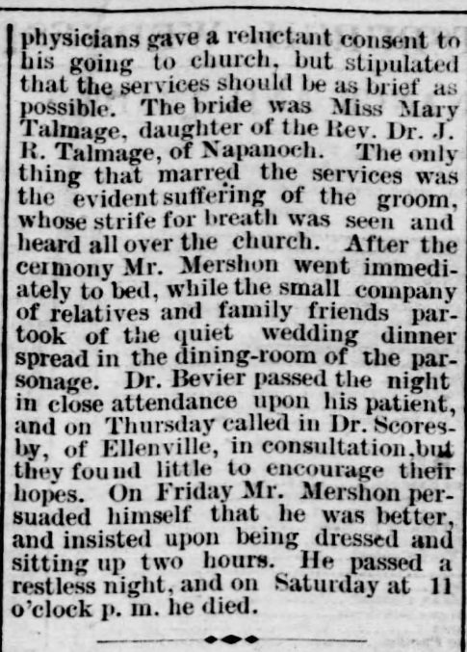

[Pittsburgh Daily Post](https://www.newspapers.com/paper/pittsburgh-daily-post/3516/)

**Pittsburgh, Pennsylvania · Wednesday, May 06, 1874**